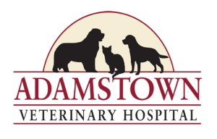Date:________________­­­­­

**Thank you for giving us the opportunity to care for your pet.**

**Please help us to better meet your needs by taking a moment to complete this information sheet.**

Owner’s Name: Spouse/Other:

Address:

City: State: Zip Code:

Email Address:

Drivers License Number: Home Telephone: _____________________

Work Telephone: Cellular Number: _____________________

What is the best time to reach you about your pet ? and at what phone number?

In case of EMERGENCY, please call: ________________ at:______________________(relationship)____________

Pet’s Name: Species:

Breed: ____________________________ Color: _____________________ Age/Birthdate: __________________

Please circle one: Male Neutered Male Intact Female Spayed Female Intact Unknown/Other

Please check your usual form of payment: Credit Card 🞏 Cash 🞏 Care Credit 🞏 (Checks are not accepted)

We consider our pets to be: part of the family 🞏, just a pet 🞏.

Who may we thank for your referral?

**Adamstown Veterinary Hospital’s policy is to prevent the spread of infectious disease and parasites. Hospitalized animals must be current on all vaccines and free of internal and external parasites. I authorize the doctor to provide vaccines and parasite control as needed for my pet. I understand that by signing below, I certify that I am the owner/authorized agent for the pet presented, and am responsible for any decisions regarding said pet. I agree to be responsible for all charges incurred in the treatment of my pet while in the care of the doctors and staff of Adamstown Veterinary Hospital (AVH) and that payment in full is due at the time of services rendered. I understand that I can request a written estimate prior to treatment if I desire. I give permission for AVH to email me at the email address provided above.**

**Signature Date**

** *We are an AAHA accredited hospital***